**MANAJEMEN BASIS DATA**

**NORMALISASI TABEL**

Disusun Guna Memenuhi Tugas Pada Mata Kuliah Manajemen Basis Data

Dosen Pengampu : I Gusti Ayu Agung Diatri Indradewi, S.Kom., M.T.



**Oleh:**

Marselinus Harson Rewo (2115091030)

Mochammad Syahrul Kurniawan (2115091031)

**PROGRAM STUDI S1 SISTEM INFORMASI**

**JURUSAN TEKNIK INFORMATIKA**

**FAKULTAS TEKNIK DAN KEJURUAN**

**UNIVERSITAS PENDIDIKAN GANESHA**

**2022**

1. **STUDI KASUS II**

Haha

1. **STUDI KASUS III**
2. **Unormalized Form**

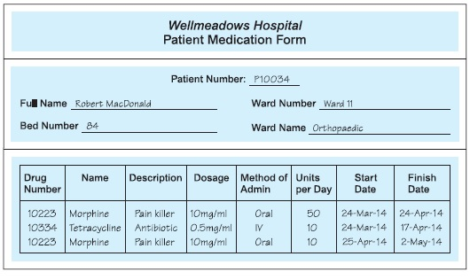

1. **1NF**

**Patient Medication Form**

|  |  |  |  |  |  |  |  |  |  |  |  |  |
| --- | --- | --- | --- | --- | --- | --- | --- | --- | --- | --- | --- | --- |
| **Patient**  **Number** | **Full Name** | **Bed**  **Number** | **Ward Number** | **Ward Name** | **Drug Number** | **Name** | **Description** | **Dosage** | **Method of Admin** | **Units Per Day** | **Start Date** | **Finish Date** |
| P10034 | Robert Macdonals | 84 | Ward 11 | Orthopaedic | 10223 | Morphine | Pain Killer | 10mg/ml | Oral | 50 | 24-Mar-14 | 24-Mar-14 |
| P10034 | Robert Macdonals | 84 | Ward 11 | Orthopaedic | 10334 | Tetracycline | Antibiotic | 0,5mg/ml | IV | 10 | 24-Mar-14 | 17-Apr-14 |
| P10034 | Robert Macdonals | 84 | Ward 11 | Orthopaedic | 10223 | Morphine | Pain Killer | 10mg/ml | Oral | 10 | 25-Apr-14 | 2-May-14 |

1. **2NF**

**Tabel Detail Patient**

|  |  |  |  |  |  |  |  |
| --- | --- | --- | --- | --- | --- | --- | --- |
| **Patient**  **Number** | **Drug Number** | **Ward Number** | **Ward Name** | **Bed**  **Number** | **Units Per Day** | **Start Date** | **Finish Date** |
| P10034 | 10223 | Ward 11 | Orthopaedic | 84 | 50 | 24-Mar-14 | 24-Mar-14 |
| P10034 | 10334 | Ward 11 | Orthopaedic | 84 | 10 | 24-Mar-14 | 17-Apr-14 |
| P10034 | 10223 | Ward 11 | Orthopaedic | 84 | 10 | 25-Apr-14 | 2-May-14 |

**Tabel Patient Tabel Drug**

|  |  |
| --- | --- |
| **Patient Number** | **Full Name** |
| P10034 | Robert Macdonals |
| P10034 | Robert Macdonals |
| P10034 | Robert Macdonals |

|  |  |  |  |  |
| --- | --- | --- | --- | --- |
| **Drug Number** | **Name** | **Describtion** | **Dosage** | **Method of Admin** |
| 10223 | Morphine | Pain Killer | 10mg/ml | Oral |
| 10334 | Tetracycline | Antibiotic | 0,5mg/ml | IV |
| 10223 | Morphine | Pain Killer | 10mg/ml | Oral |

1. **3NF**

**Tabel Detail Patient Tabel Patient**

|  |  |  |  |  |  |
| --- | --- | --- | --- | --- | --- |
| **Patient Number** | **Drug Number** | **Start Date** | **Bed**  **Number** | **Units Per Day** | **Finish Date** |
| P10034 | 10223 | 24-Mar-14 | 84 | 50 | 24-Mar-14 |
| P10034 | 10334 | 24-Mar-14 | 84 | 10 | 17-Apr-14 |
| P10034 | 10223 | 25-Apr-14 | 84 | 10 | 2-May-14 |

|  |  |
| --- | --- |
| **Patient Number** | **Full Name** |
| P10034 | Robert Macdonals |
| P10034 | Robert Macdonals |
| P10034 | Robert Macdonals |

**Tabel Ward Tabel Drug**

|  |  |
| --- | --- |
| **Ward Number** | **Ward Name** |
| Ward 11 | Orthopaedic |
| Ward 11 | Orthopaedic |
| Ward 11 | Orthopaedic |

|  |  |  |  |  |
| --- | --- | --- | --- | --- |
| **Drug Number** | **Name** | **Describtion** | **Dosage** | **Method of Admin** |
| 10223 | Morphine | Pain Killer | 10mg/ml | Oral |
| 10334 | Tetracycline | Antibiotic | 0,5mg/ml | IV |
| 10223 | Morphine | Pain Killer | 10mg/ml | Oral |